Handout no. 11

|  |  |
| --- | --- |
| **Name** | M.Umar Saleem, M.Usama, Abdul Jabbar |
| **Reg. No** | 2019-EE-356,366,376 |
| **Marks/Grade** |  |

**EXPERIMENT # 11**

**Parameter setting of Earth Fault Warning Relay for transmission line protection**

**Objective:**

At the end of this lab session students will be able to

* Use De Lorenzo power system Protection kits.
* Implement Under voltage & Overvoltage by using De Lorenzo power system Protection kits.
* Relay behaviour in three phase systems for Under Voltage and Over Voltage by changing load.
* Determination of resetting ratio.

**Introduction:**

A relay is usually an electromechanical device that is actuated by an electrical current. The current flowing in one circuit causes the opening or closing of another circuit. Relays are like remote control switches and are used in many applications because of their relative simplicity, long life, and proven high reliability. Relays are used in a wide variety of applications throughout industry, such as in telephone exchanges, digital computers and automation systems. Highly sophisticated relays are utilized to protect electric power systems against trouble and power blackouts as well as to regulate and control the generation and distribution of power. In the home, relays are used in refrigerators, washing machines and dishwashers, and heating and air-conditioning controls.

Although relays are generally associated with electrical circuitry, there are many other types, such as pneumatic and hydraulic. Input may be electrical and output directly mechanical. All relays contain a sensing unit, the electric coil, which is powered by AC or DC current. When the applied current or voltage exceeds a threshold value, the coil activates the armature, which operates either to close the open contacts or to open the closed contacts. When a power is supplied to the coil, it generates a magnetic force that actuates the switch mechanism

**Apparatus:**

* 1DL 7901TT Overhead Line model
* 1DL 2108T12 Under/Over voltage relay
* 1 DL 2109T3PV Moving iron Voltmeter
* 1 DL Buz Acoustic continuity tester
* 1 DL 1017R Resistive Load
* 1 DL 2108T02 Power Circuit Breaker
* 1 DL 2108T18 Earth Fault Warning Relay
* 1 DL 1080TT Three phase transformer
* 1 DL 2108TAL-SW Three Phase Power Supply

**Earth Fault Warning Relay:**

Earth fault is the unintended fault between the live conductor and the earth. It also occurs, because of the insulation breakdown. When the fault occurs, the short-circuit currents flow through the system, and this current is returned through the earth or any electrical equipment. This fault current damaged the equipment of the power system and also interrupted the continuity of the supply. The earth fault can be dispersed by using the restricted earth fault protection scheme. The earth fault protection scheme consists the earth fault relay, which gives the tripping command to the circuit breaker and hence restricted the fault current.

The earth fault relay is placed in the residual part of the current transformers shown in the figure below. This relay protects the delta or unearthed star winding of the power transformer against the fault current. The connection of earth fault relay with the star or delta winding of the transformer is shown in the figure below.

The current transformers are placed on both sides of the protective zone. The secondary terminal of the current transformer is connected in parallel with the relay. The output of the current transformer is equal to the zero sequence current flows in the line. The zero sequence current is absent for the external fault and for the internal fault it becomes twice the value of fault current.

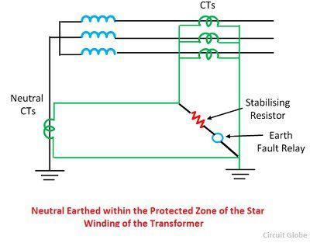

**HV transmission Lines:**

High-voltage transmission lines are used to transmit electric power over relatively long distances, usually from a central generating station to main substations. They are also used for electric power transmission from one central station to another for load sharing. High voltage (HV) transmission lines are made of high voltage (between 138 and 765 kilovolts) overhead and underground conducting lines of either copper or aluminum.

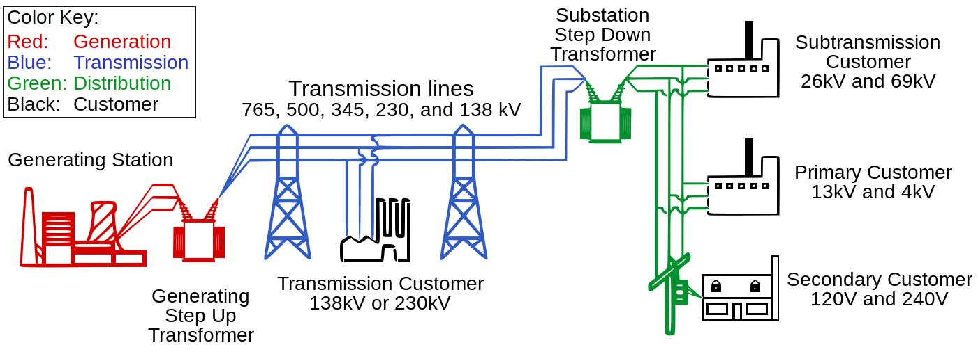

**Earth Fault Warning Relay Basic Diagram:**

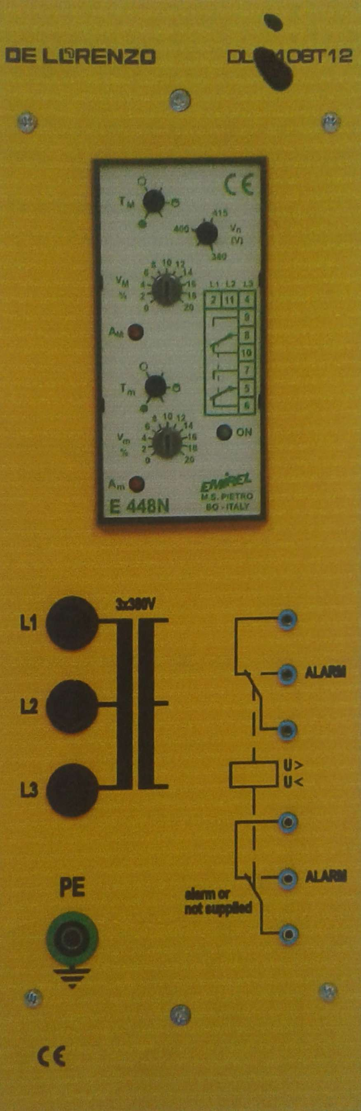

Figure 1 : VT internal wiring Diagram

**Circuit construction:**

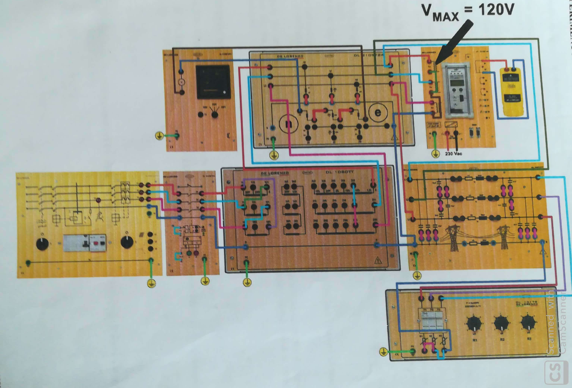

*Figure 2: Earth Fault Warning Relay in HV Lines*

**Procedure:**

* Connect circuit as shown in Fig 2.
* Set three phase power supply voltage 380v and relay is not in operation
* Observe over voltage reference voltage w.r.t to three phase supply and set load at R2.
* Slowly increased Load and observe overvoltage condition w.r.t to set values.
* Observe Over voltage reference voltage w. r .t to three phase supply.
* Slowly increase Load and observe under voltage condition w.r.t to set values.
* Observe Under voltage reference voltage w. r .t to three phase supply.
* After this observe value of phase to ground fault value by connecting each phase with neutral in three phase potential transformer and write value in table.

**Table 1:**

**Overvoltage Setting**

|  |  |
| --- | --- |
| **Vset (Volts)** | **Load Values** |
| **100** | **2 4 4** |
| **104** | **2 3 4** |
| **107** | **1 1 0** |

|  |  |  |  |  |  |  |
| --- | --- | --- | --- | --- | --- | --- |
| **Ea** | **Eb** | **Ec** | **f** | **V0** | **V1** | **V2** |
| **131** | **104** | **77** | **50.16** | **88** | **88** | **2** |
| **126** | **99** | **74** | **50.18** | **83** | **85** | **2** |
| **92** | **78** | **165** | **50.19** | **201** | **84** | **3** |

**Table 2:**

**Undervoltage Setting**

|  |  |
| --- | --- |
| **Vset (Volts)** | **Load Values** |
| **93** | **3 2 2** |
| **91** | **3 2 2** |
| **95** | **2 3 2** |

|  |  |  |  |  |  |  |
| --- | --- | --- | --- | --- | --- | --- |
| **Ea** | **Eb** | **Ec** | **f** | **V0** | **V1** | **V2** |
| **96** | **113** | **132** | **49.87** | **69** | **97** | **2** |
| **91** | **108** | **129** | **49.8** | **67** | **94** | **1** |
| **131** | **90** | **107** | **49.78** | **67** | **94** | **1** |

**Table 3:**

**Over frequency Setting**

|  |  |
| --- | --- |
| **Frequency (Hz)** | **Load Value** |
| **50.2** | **0 0 0** |
|  |  |

**Table 4**

**Under frequency Setting**

|  |  |
| --- | --- |
| **Frequency (Hz)** | **Load Value** |
| **50.27** | **2 2 2** |
|  |  |

**Observation:**